**Kaderisasi Workshop HME 2017**

**Tugas Kelompok 0**

1. **Data Kelompok**

Kelompok : B dan G

|  |  |
| --- | --- |
| No | Nama |
| 1 | Alif Ilham Madani |
| 2 | Aditya Dwi |
| 3 | Flavio Lemuel |
| 4 | Jason William Setiawan |
| 5 | Gusti T Winata |
| 6 | M Rivandi Fadli |
| 7 | Tegar Satria Nurhuda |

1. **Dokumentasi Pengerjaan**

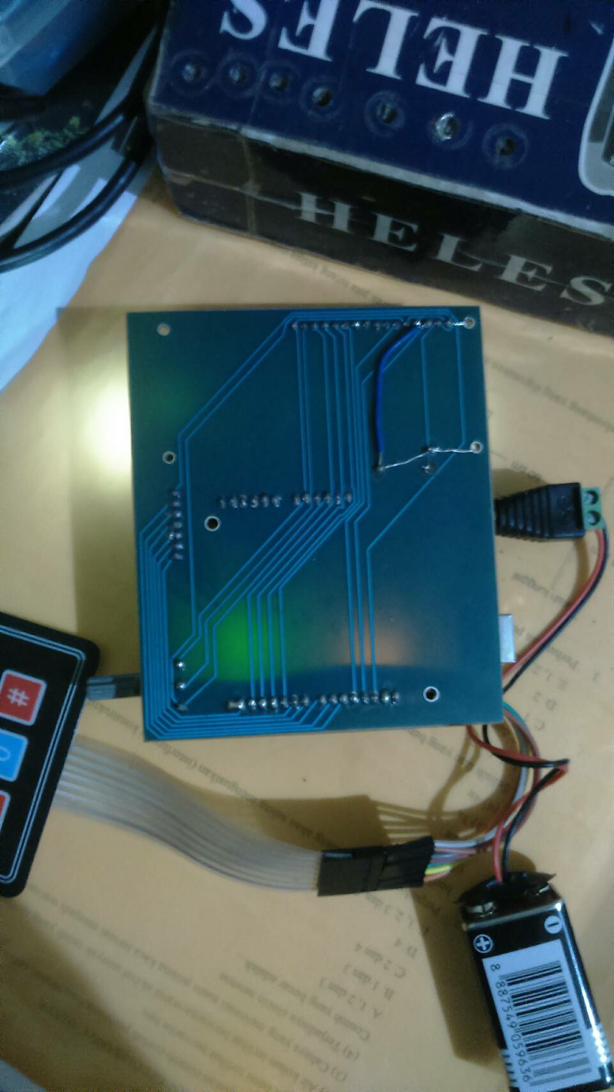 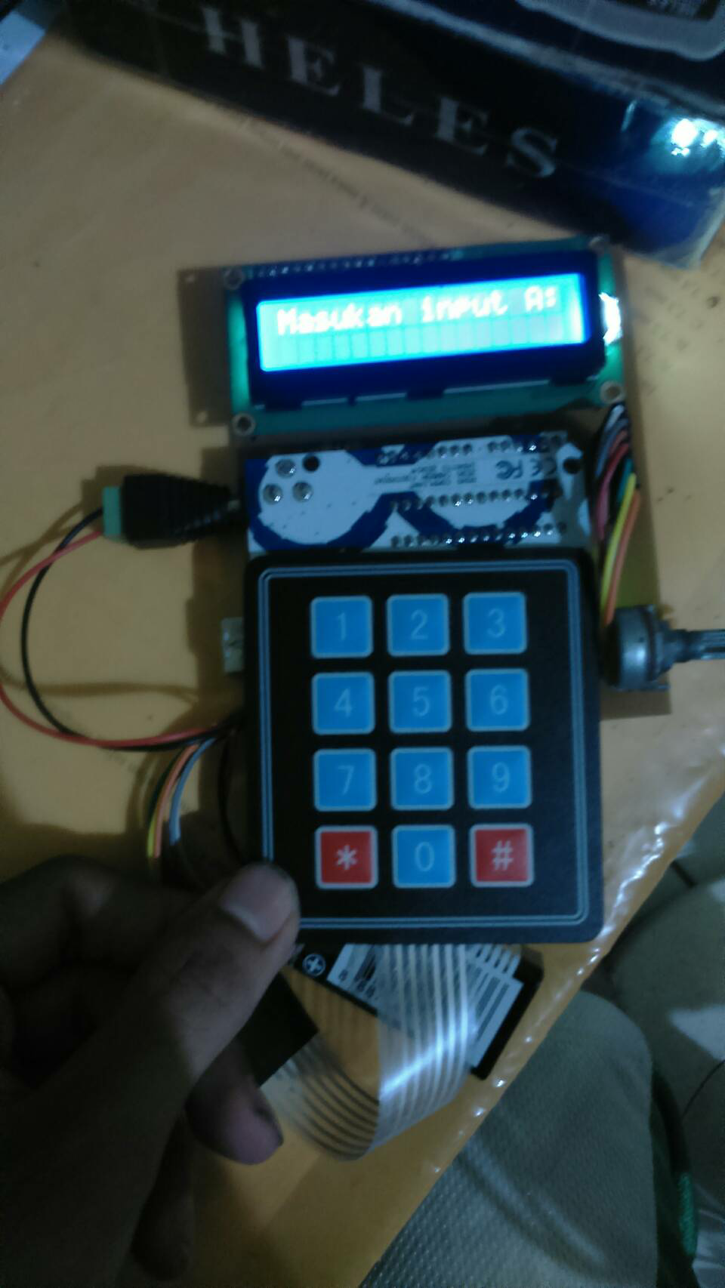

1. **Keterangan Tambahan**

Kesulitan yang dihadapi dalam pengerjaan WSCalc ini terletak pada pendesaianan PCB yang masih ada cacat di bagian peletakan resistor untuk kecerahan layar. Resistor yang di desain belum lengkap dan sesuai nilainya, sehingga perlu di tambah kabel jumper.

Selain itu, pada pemrograman arduino, masih terdapat bug untuk inputan yang tidak sesuai spesifikasi. Namun, program yang ada sudah berjalan dengan baik untuk operasi tambah, kurang, kali, bagi, dan pangkat.

Untuk casing, sudah di desain dengan inventor oleh salah satu anggota kelompok, namun setelah pcb dicetak, penempatan lubang-lubang casingnya tidak sesuai, sehingga perlu revisi desain casing. Namun karena tidak sempat, maka casing tidak jadi digunakan.

**Lampiran – *Source Code Arduino***

// include the library code:

#include <LiquidCrystal.h>

#include <Keypad.h> //import keypad library

#include <math.h> // import library math

///////////////////////////////////////////////////////VARIABLES///////////////////////////////////////////

//VARIABLES TO PARSE FLOATING ANSWER INTO WHOLE NUMBER AND DECIMAL PARTS///

char outresult[20];

String OutResult;

int decimal_location;

String whole_number;

String decimal_number;

//VARIABLES USED TO SCROLL TOP LINE//

bool STOP;

bool cek;

int de = 0;

//FOR OPERATORS//

char operators;

//INPUT VARIABLES//

char input[9]; //buffer for input characters

float firstnumber = 0; //stores first number

float secondnumber = 0; //stores second number

float response = 0; //stores "answer"

float sum1 = 0; //stores input 1

float sum2 = 0; //stores input 2

bool positive = 1; //indicates positive number

int lcdcolumnindexrow1 = 1; // used to indicate location of input key

//FUNCTION VARIABLES//

int function = 9; //stores currently selected function

const int number_of_functions = 10;

int mode = 2; // select normal operation (1) or mystery function (0)

bool toggle = 1;

int level = 0; // stores level for the game

const int number_of_levels = 10;

///////////////////////////////////////////////////////KEYPAD SETUP///////////////////////////////////////

const byte ROWS = 4; // Four rows

const byte COLS = 3; // Four columns

// Define the Keymap

char keys[ROWS][COLS] = {

{'1', '2', '3'},

{'4', '5', '6'},

{'7', '8', '9'},

{'*', '0', '#'}

};

// Connect keypad ROW0, ROW1, ROW2 and ROW3 to these Arduino pins.

byte rowPins[ROWS] = { 0, 6, 7, 8 };

// Connect keypad COL0, COL1, COL2, and COL3 to these Arduino pins.

byte colPins[COLS] = { 9, 10, 13 };

// Create the Keypad

Keypad kpd = Keypad( makeKeymap(keys), rowPins, colPins, ROWS, COLS );

///////////////////////////////////////////////////////LCD SETUP///////////////////////////////////////

const int rs = 12, en = 11, d4 = 5, d5 = 4, d6 = 3, d7 = 2;

LiquidCrystal lcd(rs, en, d4, d5, d6, d7);

void setup() {

// put your setup code here, to run once:

// set up the LCD's number of columns and rows:

lcd.begin(16, 2);

// Print a message to the LCD.

lcd.print("WSCalc 2017");

// DISPLAY ROW 1

for (int i = 0; i < 3; i++) {

lcd.setCursor(0, 1);

lcd.write("Made by Kelompok B&G");

delay(500);

lcd.setCursor(0, 1);

lcd.write("ade by Kelompok B&G");

delay(500);

lcd.setCursor(0, 1);

lcd.write("e by Kelompok B&G");

delay(500);

lcd.setCursor(0, 1);

lcd.write(" by Kelompok B&G");

delay(500);

}

//CLEAR LCD

lcd.clear();

}

void loop() {

sum1=0;

sum2=0;

firstnumber = 0;

secondnumber = 0;

int c1=0; //cursor input1

////////////////////////INPUT A//////////////////////////////

lcd.clear();

STOP = false;

cek = true;

do

{

// put your main code here, to run repeatedly:

lcd.setCursor(0, 0);

lcd.print("Masukan input A:");

char key = kpd.getKey();

if (key)

{

// set the cursor to column 9, line 1

//(note: line 1 is the second row, since counting begins with 0):

lcd.setCursor(c1, 1);

//Print the detected key

lcd.print(key);

++c1;

sum1 = sum1*10 + firstnumber;

switch (key) {

case '1':

firstnumber = 1;

cek = true;

break;

case '2':

firstnumber = 2;

cek = true;

break;

case '3':

firstnumber = 3;

cek = true;

break;

case '4':

firstnumber = 4;

cek = true;

break;

case '5':

firstnumber = 5;

cek = true;

break;

case '6':

firstnumber = 6;

cek = true;

break;

case '7':

firstnumber = 7;

cek = true;

break;

case '8':

firstnumber = 8;

cek = true;

break;

case '9':

firstnumber = 9;

cek = true;

break;

case '0':

firstnumber = 0;

cek = true;

break;

case '*':

STOP = true;

break;

}

}

} while (STOP == false);

lcd.setCursor(0, 1);

/////////////////OPERATORS////////////////////////

lcd.clear();

bool STOP2 = true;

int change = 1;

do {

lcd.setCursor(0, 0);

lcd.print("Masukan Operator:");

char key = kpd.getKey();

///PENGEMBALI OPERATOR LOOP///

if (change == 6) {

change = 1;

}

switch (key) {

case '*': if (change == 1) {

lcd.setCursor(0, 1);

lcd.print('*');

change = change + 1;

} else if (change == 2) {

lcd.setCursor(0, 1);

lcd.print('/');

change = change + 1;

} else if (change == 3) {

lcd.setCursor(0, 1);

lcd.print('+');

change = change + 1;

} else if (change == 4) {

lcd.setCursor(0, 1);

lcd.print('-');

change = change + 1;

} else {

lcd.setCursor(0, 1);

lcd.print("^");

change = change + 1;

}

break;

case '#':

STOP2 = false;

break;

}

} while (STOP2 == true);

////////////////INPUT B//////////////////////////

int c2=0; //cursor input 2

lcd.clear();

STOP = false;

cek = true;

do

{

// put your main code here, to run repeatedly:

lcd.setCursor(0, 0);

lcd.print("Masukan input B:");

char key = kpd.getKey();

if (key)

{

// set the cursor to column 9, line 1

//(note: line 1 is the second row, since counting begins with 0):

lcd.setCursor(c2, 1);

//Print the detected key

lcd.print(key);

++c2;

sum2 = sum2*10 + secondnumber;

switch (key) {

case '1':

secondnumber = 1;

cek = true;

break;

case '2':

secondnumber = 2;

cek = true;

break;

case '3':

secondnumber = 3;

cek = true;

break;

case '4':

secondnumber = 4;

cek = true;

break;

case '5':

secondnumber = 5;

cek = true;

break;

case '6':

secondnumber = 6;

cek = true;

break;

case '7':

secondnumber = 7;

cek = true;

break;

case '8':

secondnumber = 8;

cek = true;

break;

case '9':

secondnumber = 9;

cek = true;

break;

case '0':

secondnumber = 0;

cek = true;

break;

case '*':

STOP = true;

break;

}

}

} while (STOP == false);

////OPERATING/////

lcd.clear();

lcd.setCursor(0, 0);

lcd.print("HASILNYA >.<");

char key = kpd.getKey();

if (change == 2) {

lcd.setCursor(0, 1);

lcd.print(sum1 * sum2);

} else if (change == 3) {

lcd.setCursor(0, 1);

lcd.print(sum1 / sum2);

} else if (change == 4) {

lcd.setCursor(0, 1);

lcd.print(sum1 + sum2);

} else if (change == 5) {

lcd.setCursor(0, 1);

lcd.print(sum1 - sum2);

} else {

lcd.setCursor(0, 1);

lcd.print(pow(sum1,sum2));

}

delay(5000);

}